 | 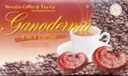 | 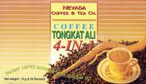 | 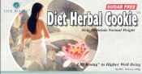 | 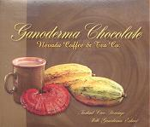 | 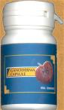

Reishi - Ganoderma Lucidum
LCR Gano Brand
www.LCRGano.com
Larson Century Ranch
Telephone: 509-758-5445, 509-758-5701,
E-Mail: Rick@LarsonCenturyRanch.com
Other Common Names: Ling chih, Ling zhi, Mannentake, Ganoderma Lucidum
As recorded in the oldest Chinese medical text, reishi is the "king of herbs", the superior herb. Continuous intake will achieve the best results.  Western culture has often frowned on mushrooms, even fearing the small innocuous forest growth. The French prize their truffles, but even truffles and other edible fungi and mushrooms are not as highly valued or show as much potential as a species of mushrooms called Ling Zhi or Reishi. | 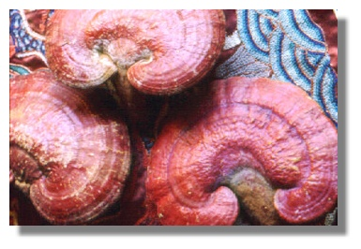
Reishi mushrooms are polypore mushrooms. Mushrooms are the fruiting body and reproductive structure of a higher order fungus organism, much like an apple is the fruit of an apple tree. The actual mushroom "tree" is a fine thread-like network called mycelium. This mycelium is for the most part subterranean, living in soil, logs and other organic litter.
Unlike green plants, which produce many of their own nutrients by photosynthesis, mushrooms primarily get their nutrients from dead organic matter or soil. Mushrooms and their mycelium are nature's original recyclers. Without them, the planet surface would be piled high with dead, decaying material.
Mushrooms rise out of the mycelium when the right nutrients are amassed and the right environmental conditions are present. Mushrooms release spores at maturity. The wind spreads them and when they land on the right spot, the cycle starts over again.

Reishi often is associated with health and recuperation, longevity, wisdom, and happiness.
Known as reishi or mannentake to the Japanese and Ling Zhi to the Chinese, G. lucidum is renown for its medicinal properties. It is believed that certain triterpenes and polysaccharides may account for the multiple activities of Reshi. Thus, considerable time and effort has gone into the isolation and characterization of these compounds.
Reishi is a basidiomycete, lamellaless fungus belonging to the family of polyporaceae. In nature, it grows in densely wooded mountains of high humidity and dim lighting. It is rarely found since it flourishes mainly on the dried trunks of dead plum, guercus serrata or pasonia trees. Out of 10,000 such aged trees, perhaps 2 or 3 will have reishi growth, therefore it is very scarce indeed.
Relatively rare and undiscovered in the West, Reishi and other mushrooms have been revered as herbal medicines for thousands of years in Japan and China. Emperors of the great Chinese dynasties and Japanese royalty drank teas and concoctions of the mushroom for vitality and long life. The ancient Taoists were constantly searching for the elixir of eternal youth, and Reishi was believed to be among the ingredients.
In ancient time, reishi in medicine was considered so auspicious that its medical efficacy has been attested to in the oldest Chinese medical text (presumed to be over 2,000 years old). The book, which is known in Japan as "Shinnoh Honsohkyo", is now accepted as being the original textbook of Oriental medical science. In it, 365 kinds of medicines are classified and explained. The medicines are basically classified into 3 categories:
- 120 of them are declared to be "superior" medicines;
- another 120 are classified as "average" medicines;
- and the remaining 125 are placed in the "fair" category.
The "superior" medicines are called "God's Herbs" and they are for perpetual youth and longevity - the medicines of the legendary wizards. The "average" category medicines are those which can be taken as a tonic, and those in the "fair" category are taken to remedy specific ailments. One must be careful about the volume taken of the "average" and "fair" category medicines, and should never take them continuously. However, the book states that for "superior" medicines, any amount can be taken as desired on a continuous basis with no unfavorable effects. Of the superior medicines listed in the text, reishi was rated number one.
Ganoderma and its derivatives are not pharmaceuticals and have not undergone rigorous clinical trials.

- Linda McGlasson, Assistant Editor. Health Foods Business/January 1992 Consumer Education Series. Reishi: Ancient Medicine Is Modern Hope
- Kim HS, Kacew S, Lee BM. Carcinogenesis 1999 Aug;20(8):1637-40. In vitro chemopreventive effects of plant polysaccharides (Aloe barbadensis miller, Lentinus edodes, Ganoderma lucidum and Coriolus versicolor).
- Kim KC, Kim IG. Int J Mol Med 1999 Sep;4(3):273-7. Ganoderma lucidum extract protects DNA from strand breakage caused by hydroxyl radical and UV irradiation.
- Hijikata Y, Yamada S. Am J Chin Med 1998;26(3-4):375-81 Effect of Ganoderma lucidum on postherpetic neuralgia.
- Wasser SP, Weis AL. Crit Rev Immunol 1999;19(1):65-96. Therapeutic effects of substances occurring in higher Basidiomycetes mushrooms: a modern perspective. International Centre for Cryptogamic Plants and Fungi, Institute of Evolution, University of Haifa, Israel.

Reishi, also known as the Happy herb..
Like one's health, Reishi was considered to be worth more than any jewel and why it has been called the "Herb of Good Fortune" and "Happy Herb". Anyone finding it was considered to be extremely lucky. Reishi was so sought after people really did risk their lives trekking through inhospitable jungles and climbing high mountains to find the elusive "elixir of life". There are ancient tales in Asia about Reishi bringing the dead back to life. It has been called "Miraculous Herb" but could it really be that miraculous? This seems to be a reference to Reishi's ability to boost all bodily systems. From these tales it would appear people who were very depleted and barely alive were restored to good health thanks to Reishi.
Given that these tales exist it suggests there must have been instances of amazing, if not miraculous cures having occurred.
In BC 219 a Chinese Emperor sent an expedition to Japan..never to be seen again. It is thought they settled there and introduced the beginnings of Kampo, Japanese Traditional Medicine. Reishi was so valued it was picked almost to extinction with only 1 or 2 found among 1000's of trees. This scarcity and the difficulty growing it on a commercial scale are why Reishi is not well known in the West. Although commercial cultivation took off in the late 1980's there was still not enough to go round as most was bought by the Japanese where it is a best selling herbal remedy. Despite its reputation, Reishi cannot be found in many western herbals. Possibly this is simply because it was unobtainable.

Names for Reishi
Reishi or lingzhi its Chinese name, has also been called:
'Miraculous Herb' | 'Medicine of Kings' | 'Auspicious Herb'
'God?s Herb' | 'The Great Protector' | 'Herb of Good Fortune'
'Long Life Herb' | 'Mushroom of Immortality' | 'Marvellous herb'
 | 'Lucky Herb'
In Japan it is called Mannetake, "thousand year mushroom"

